**Gitlab**

**1: Creation GitLab runner**

**Steps:**

* **Launch instance and allow all ports**
* **If you are knew to git lab then follow the steps to create gitlab**
* **Go to ruuner section and click on create new runner**
* **Copy and paste command to configure gitlab runner**

**Launch ec2 instance**

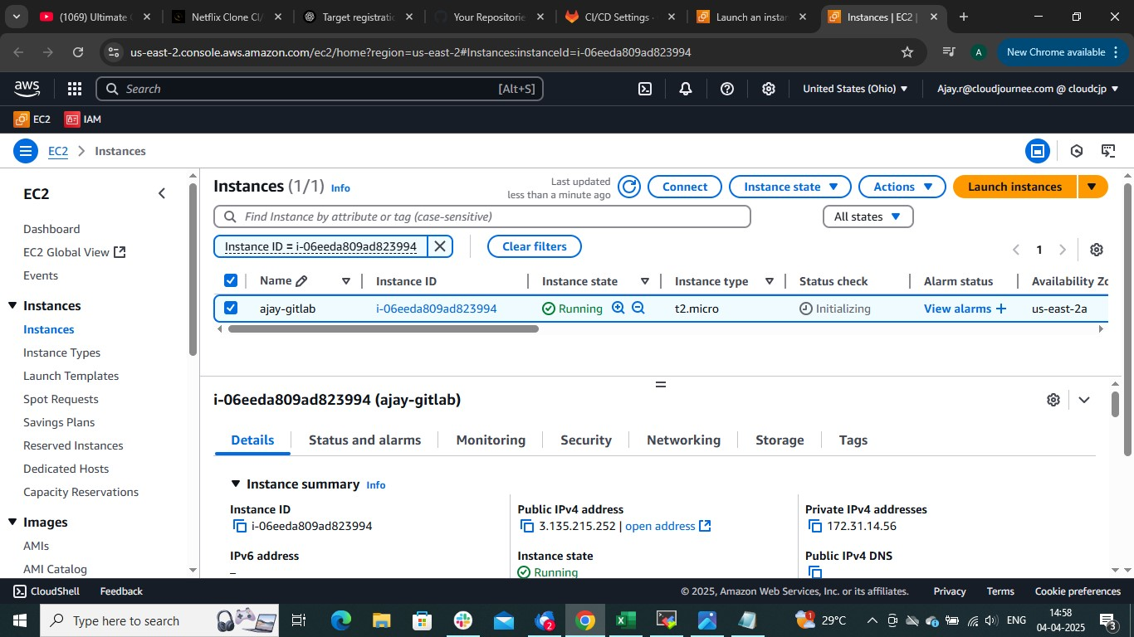

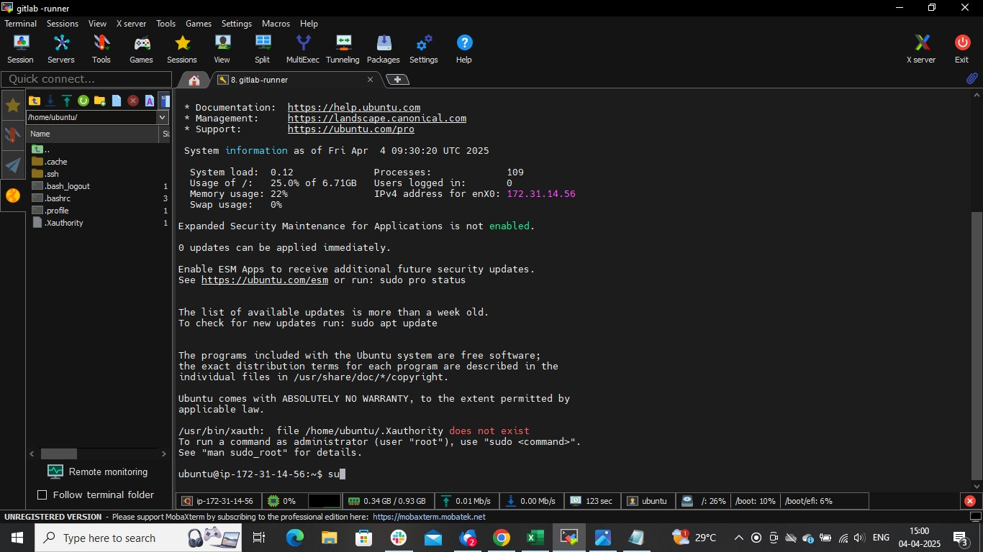

**Create gitlab account**

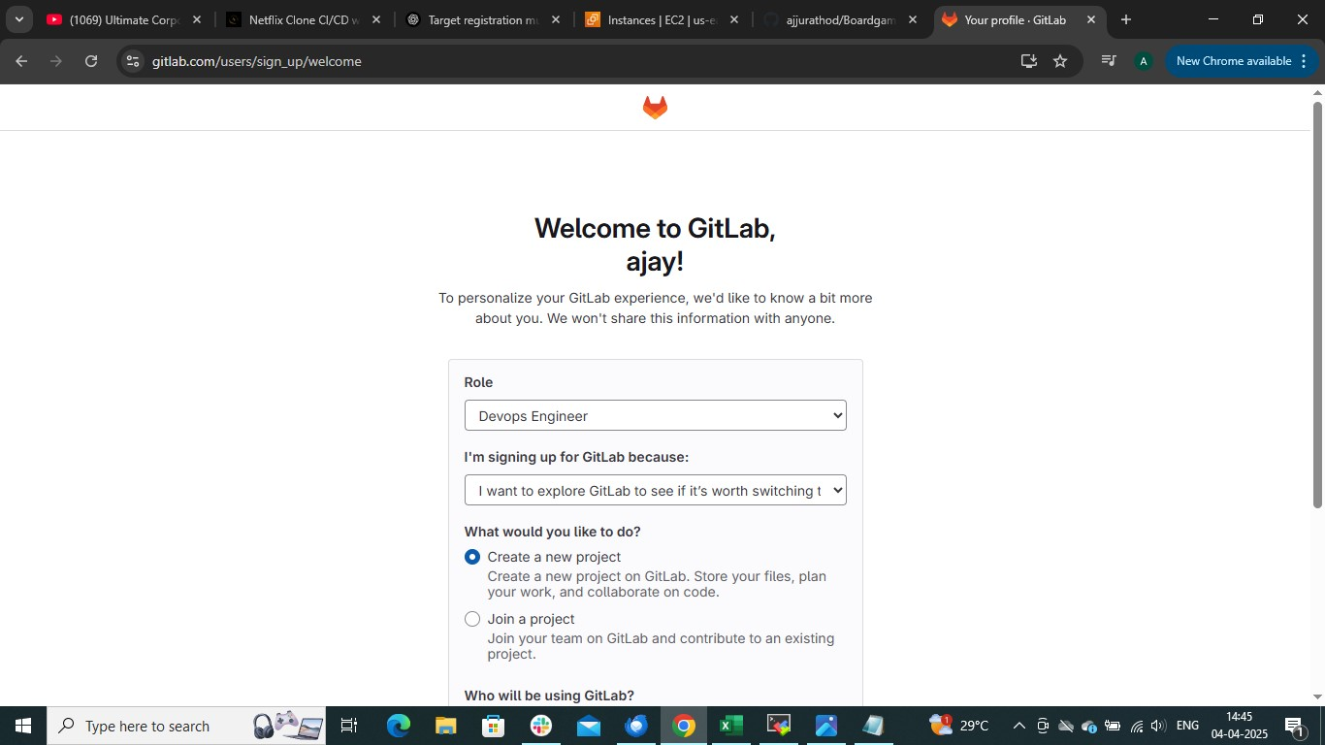

**🡺import from github(To import github repo , to perform ci cd action on repo which is hosted in github )**

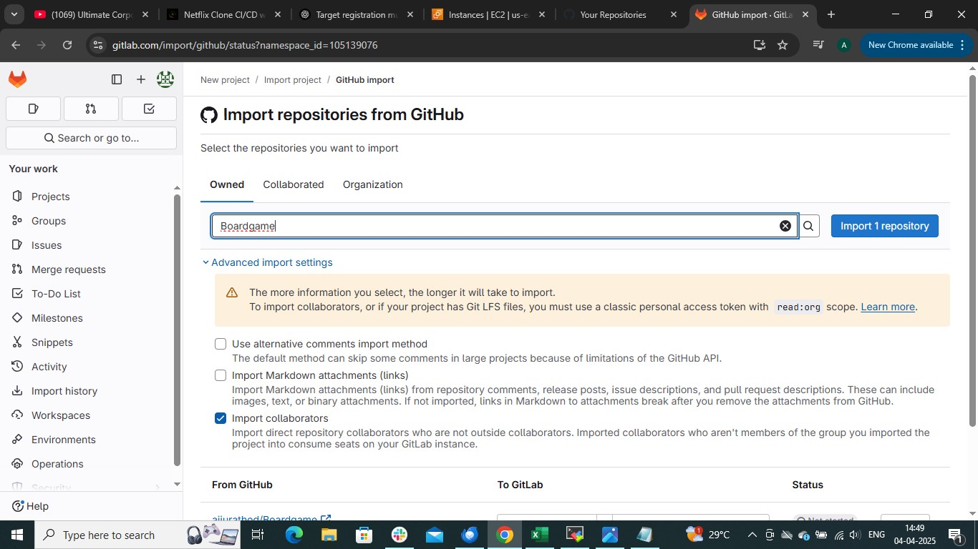

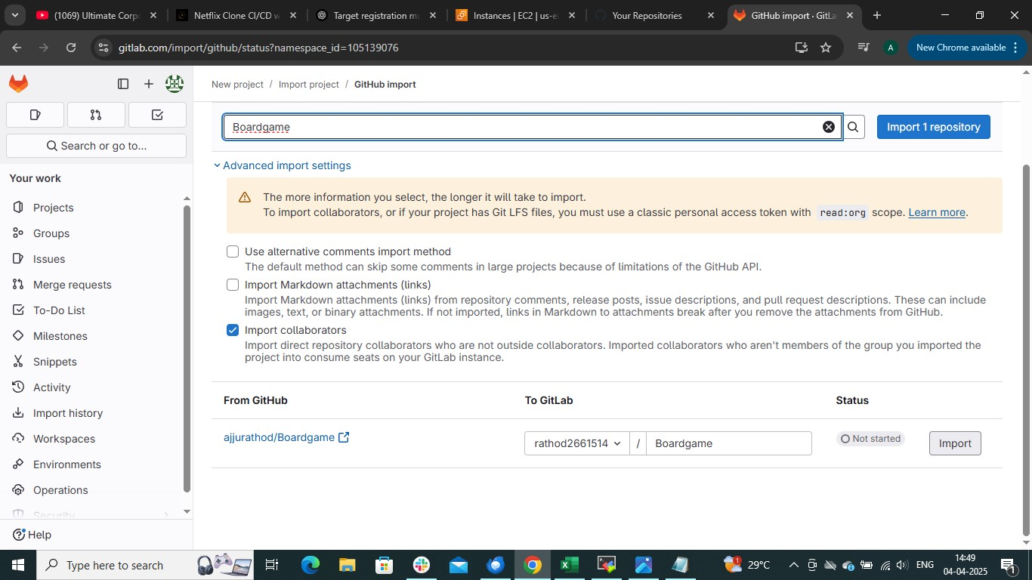

**Once the repo is imported the page will look like this**

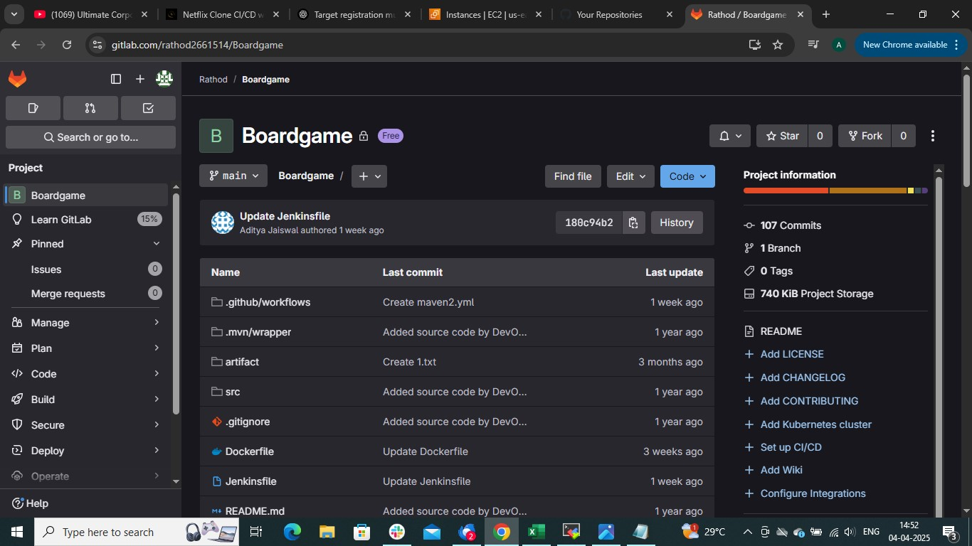

**🡺setting (left downside)🡺CICD**

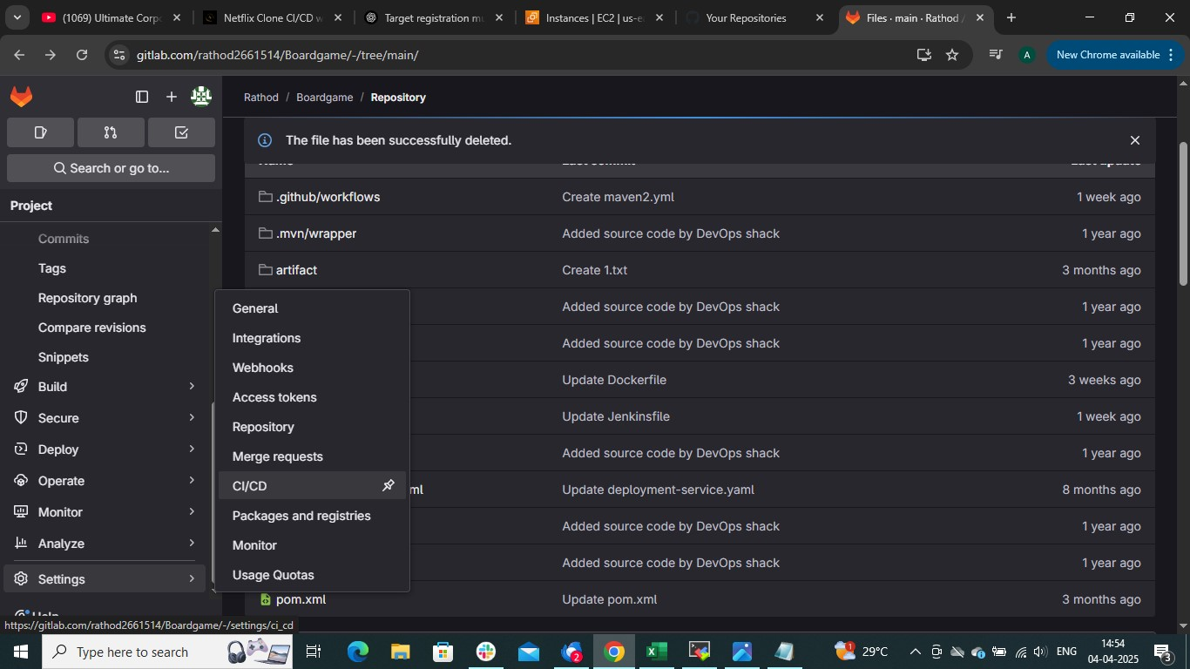

**This page will open**

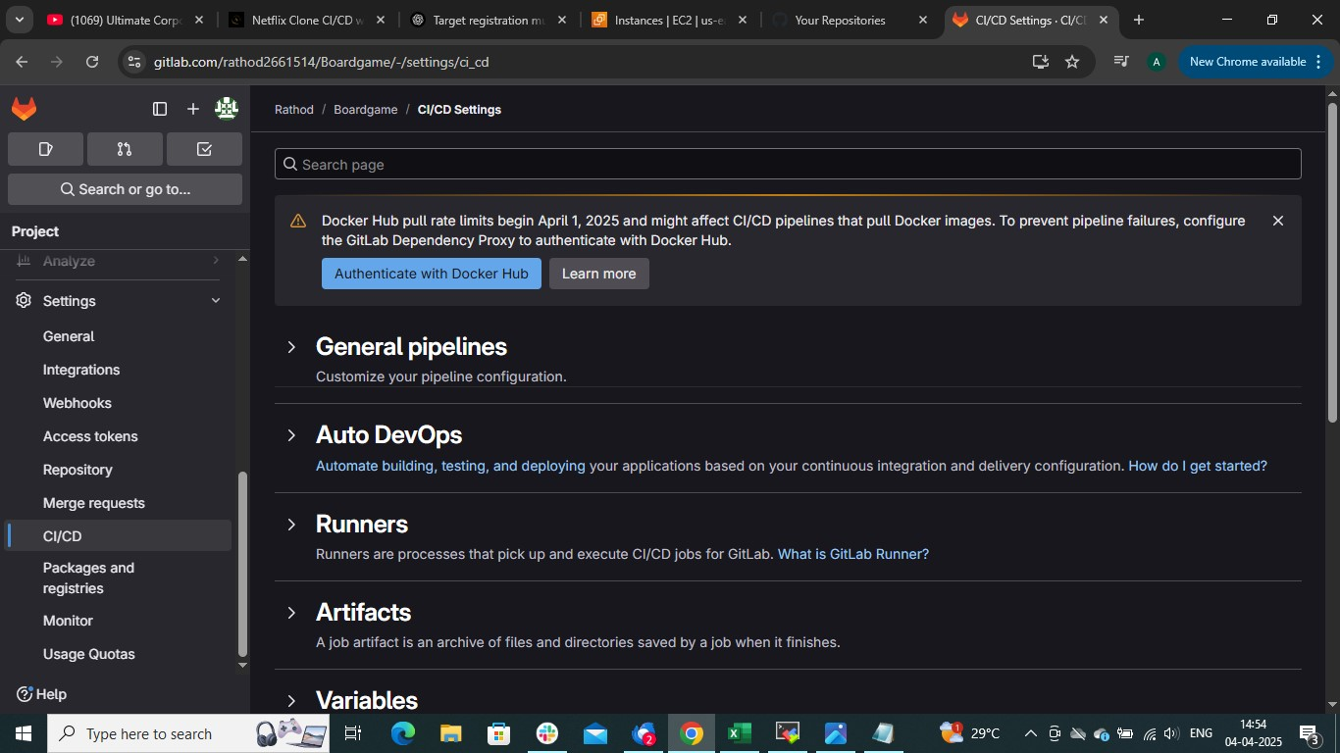

**🡺runner 🡺new project runner**

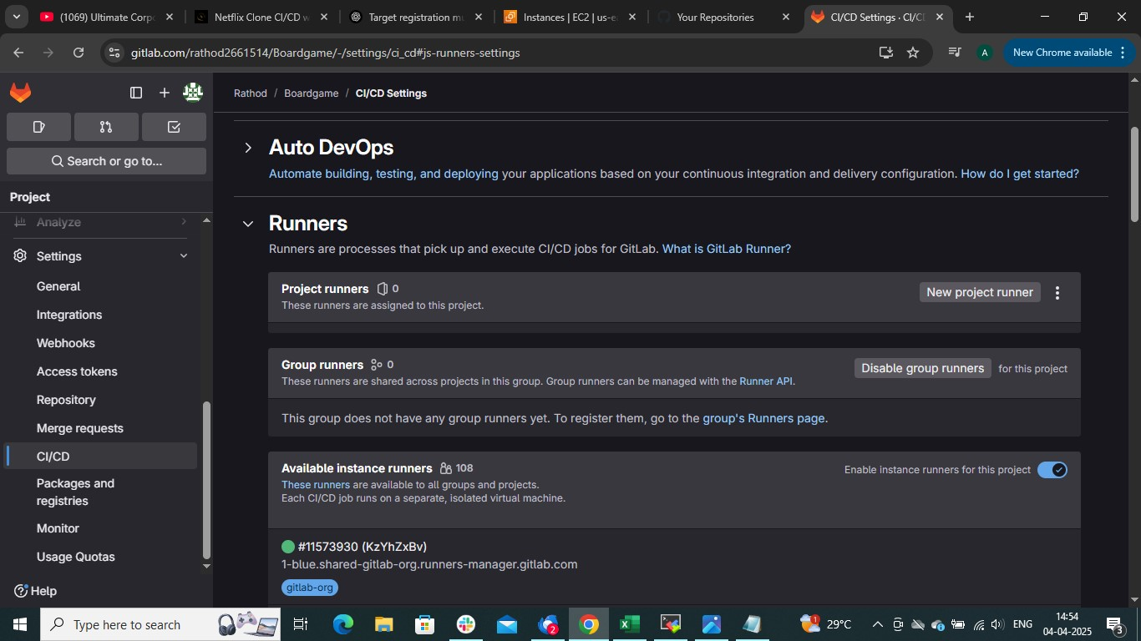

**Give tags and tick box of run untagged job**

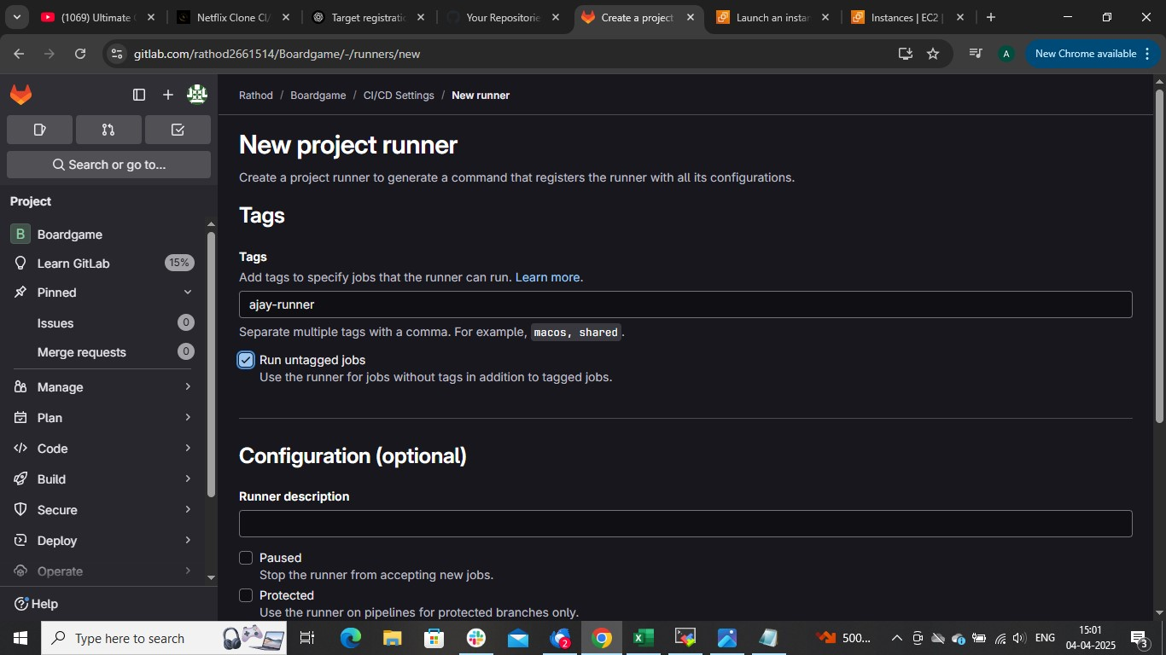

**Rest is same 🡺create**

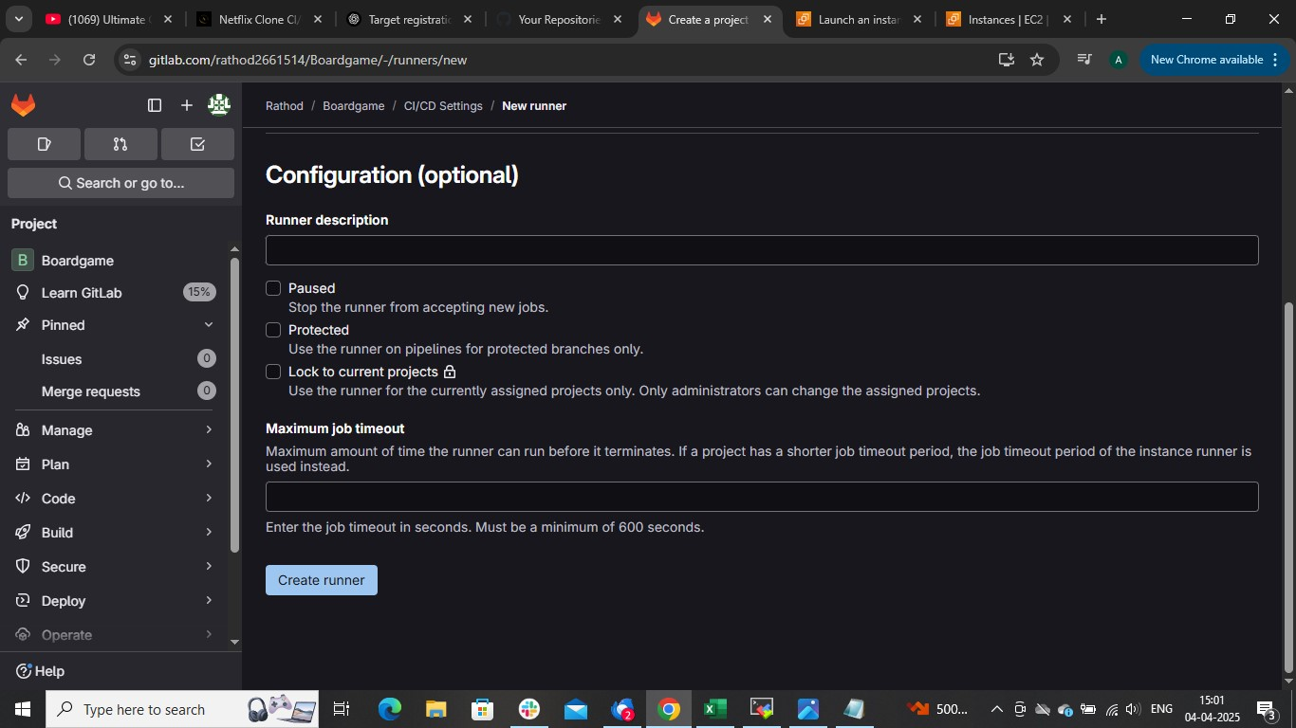

**Choose linux**

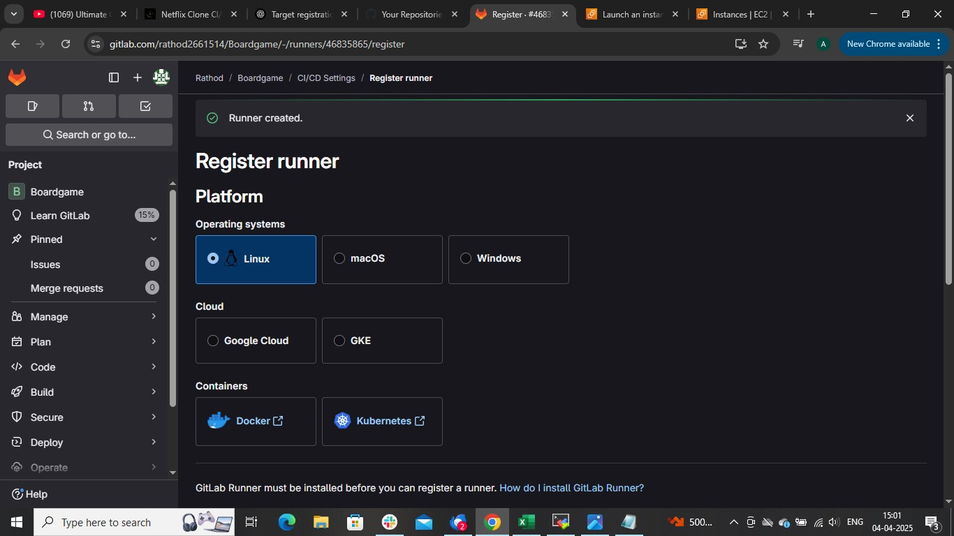

**🡺HOW TO INSTALL GITLAB RUNNER (copy the command and paste it in linux)**

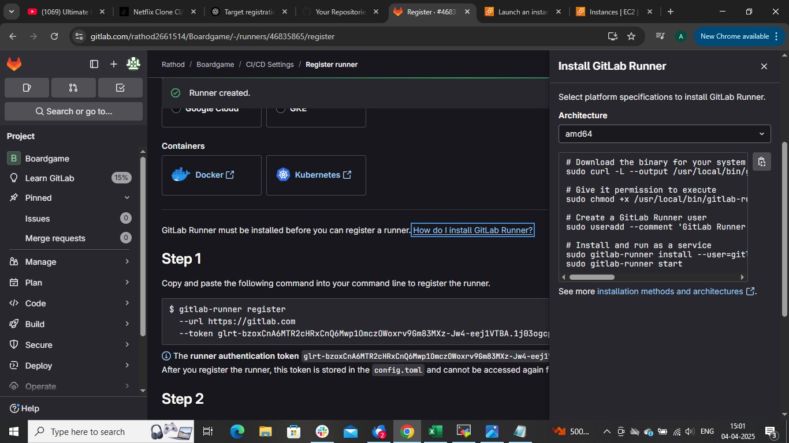

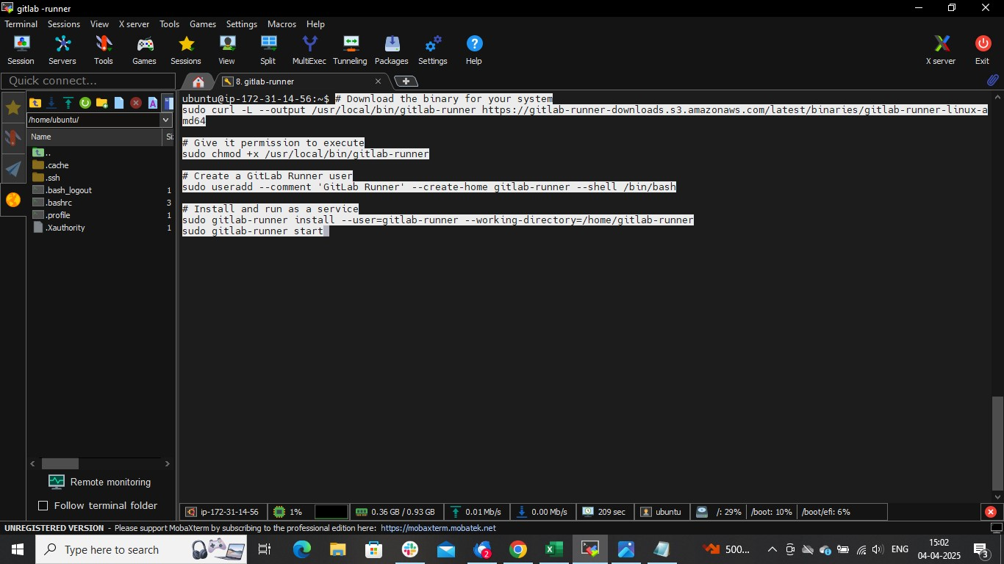

**Gitlab runner is installing**

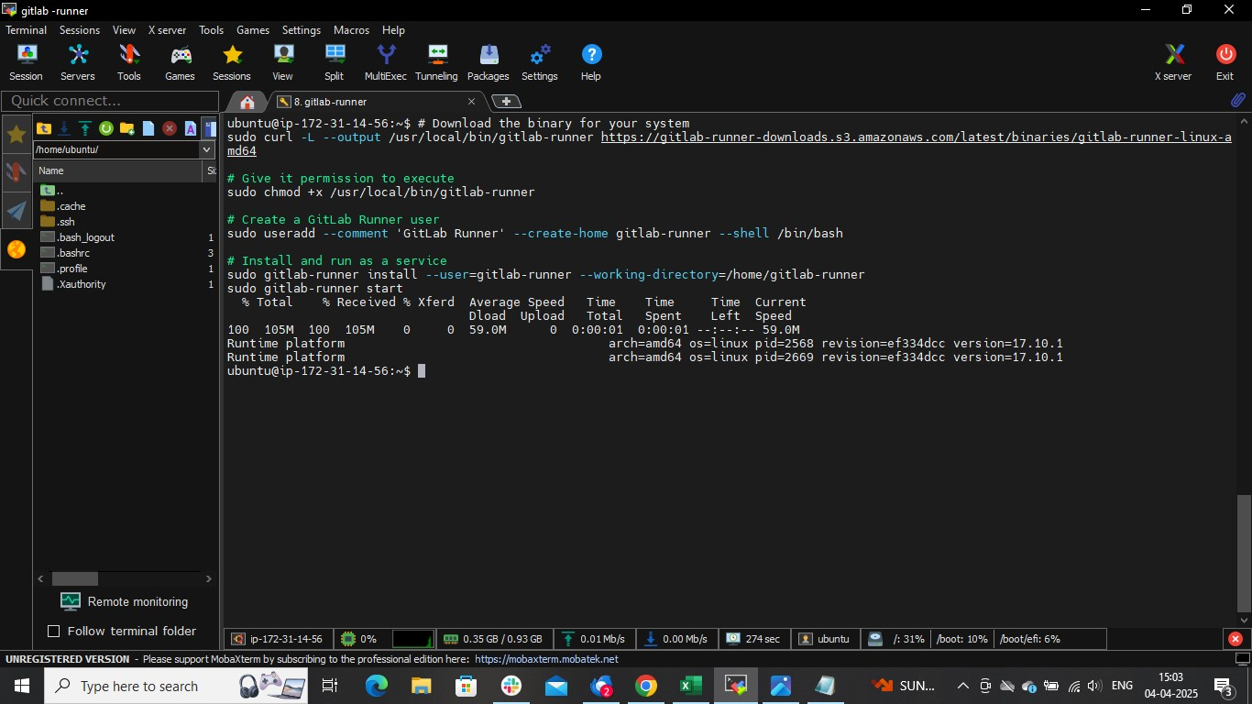

**Now copy the step 1 command**

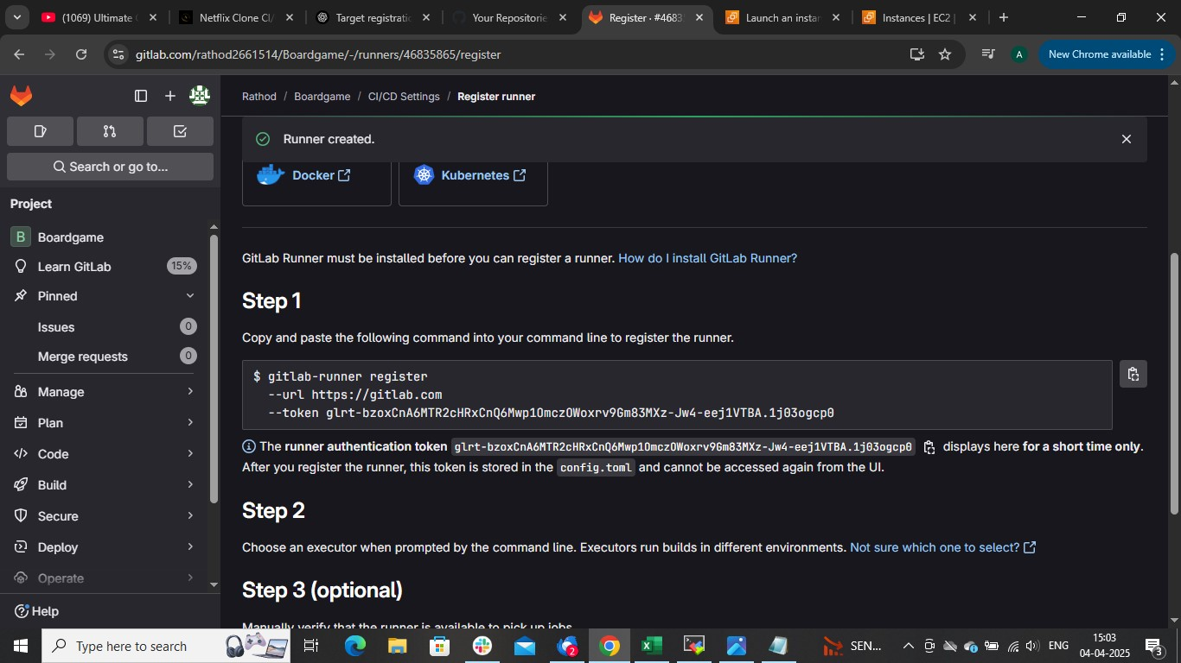

**Paste it in linux machine where the runner is running**

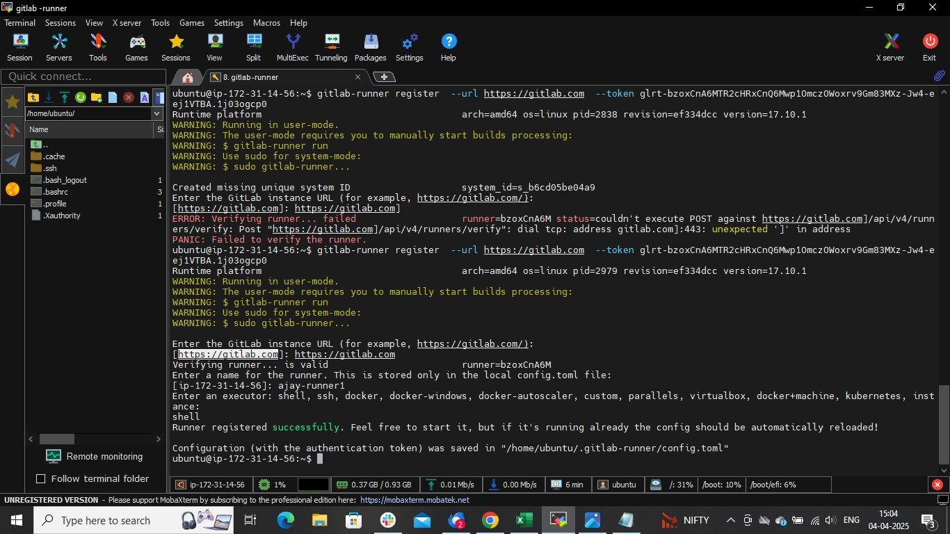

**Pit gitlab url as : htttp://gtilab.com**

**And choose executor as : shell**

**And run command: gitlab-runner run**

**That’s it**

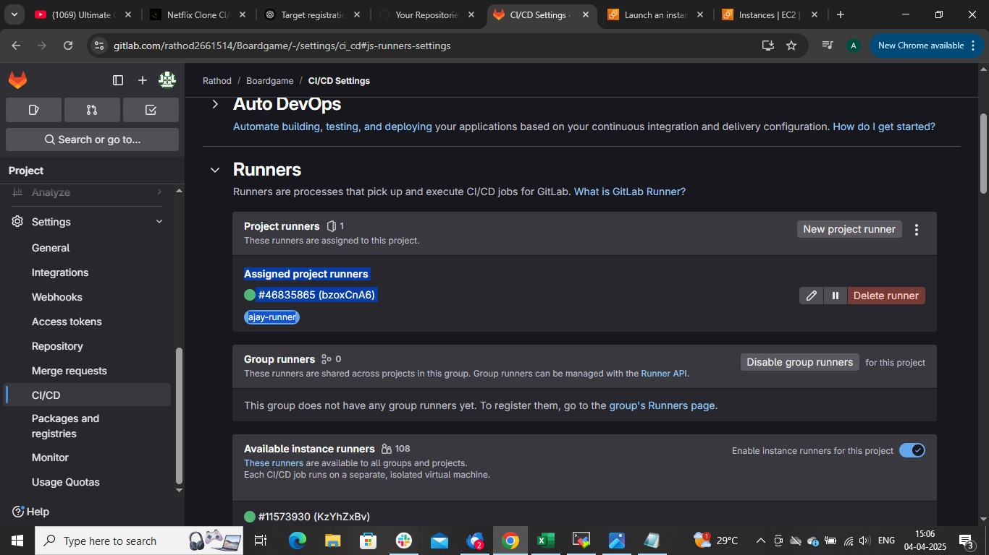

**Gitlab CICD**

**Steps:**

* **Open gitalab and import git repo**
* **Launch an instance and configure runner**
* **Build the application using maven**
* **Install and configure sonarqube with gitlab (OPTIONAL)**
* **Configure dockerhub username and password in variable**
* **Create one more instance and configure it as worker by Kubernetes cluster (install k8s master where runner is running**
* **Create ci cd yaml file (.gitlab-ci.yaml)**
* **Once you commit pipeline will run**

**Create gitlab account and configure runner as shown in above steps**







**(Optional)**

**Now to install and configure sonarqube for code quality analysis**

**IN CI CD I have installed sonarqube docker, maven kubectl which is required for the this project follow that**

stages:

    - install

    - build and test

    - build and push

    - deploy

# To install maven ,docker, and sonarqube

install_job:

    stage: install

    script:

        - sudo apt update -y

        - sudo apt install  maven -y

        - curl -fsSL https://get.docker.com -o get-docker.sh

        - sudo sh get-docker.sh

        - sudo systemctl enable docker

        - sudo systemctl start docker

        - sudo systemctl status docker

        - sudo docker rm -f $(sudo docker ps -a -q)

        - sudo docker run -td --name sonar-cont -p 9000:9000 sonarqube:latest

        - sudo docker ps

        - sudo apt install openjdk-11-jdk -y

        - export JAVA_HOME=/usr/lib/jvm/java-11-openjdk-amd64

        - export PATH=$JAVA_HOME/bin:$PATH

        - sudo snap install kubectl --classic

    tags:

        - ajay

**In this I have used**

- sudo apt install openjdk-11-jdk -y

- export JAVA_HOME=/usr/lib/jvm/java-11-openjdk-amd64

- export PATH=$JAVA_HOME/bin:$PATH

**This commads I was getting dependency compability error**

**We can use just this command**

sudo apt install openjdk-17-jdk

**For docker I have used standard documentation to install it**

**to avoid container run time mismatch error**

        - curl -fsSL https://get.docker.com -o get-docker.sh

        - sudo sh get-docker.sh

**We can use this command to install docker**

sudo apt install docker.io -y

**🡺commit changes**

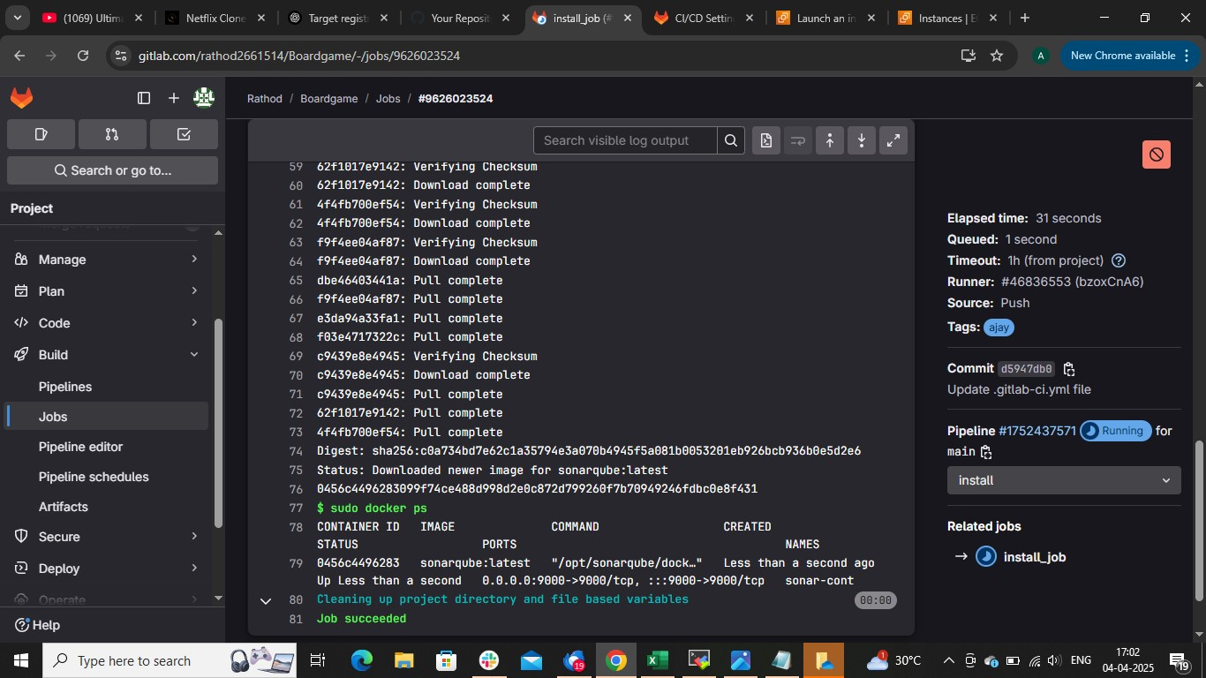

**Search publicIP:9000**

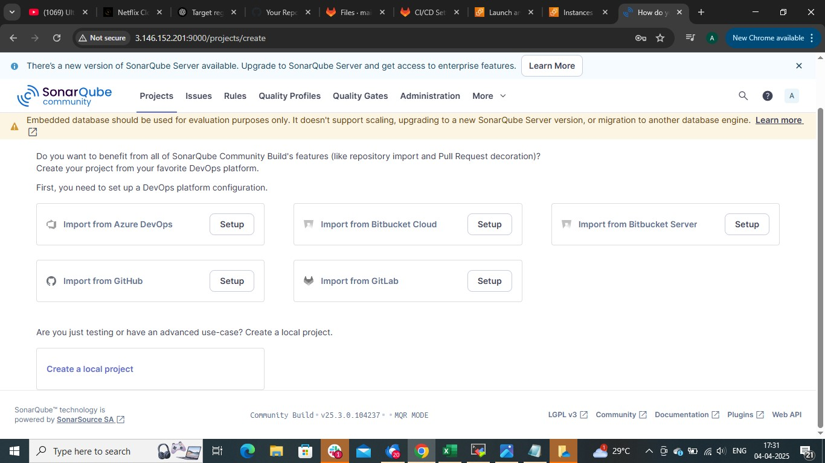

**🡺import from gitlab**



**Once we 🡺 imoport from gitlab**

**It will ask name (give any), server (copy the same example server),access token**

**Need to create access token to integrate gitlab with sonarqube**

**On gitlab page**

**🡺home Icon🡺edit profile 🡺access token and create access token**

**Copy and paste it in sonarserver**

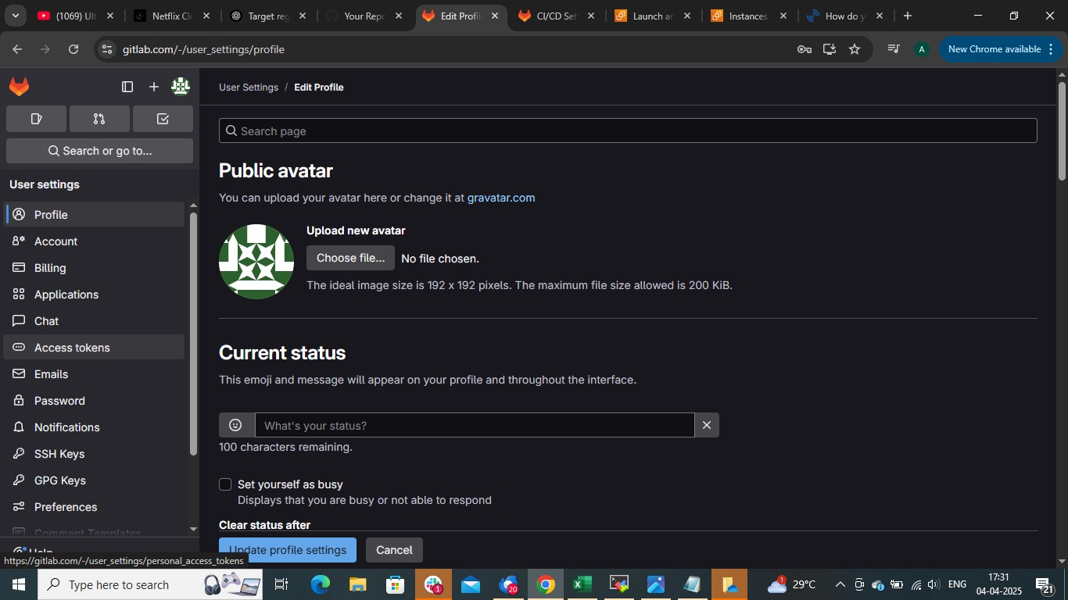

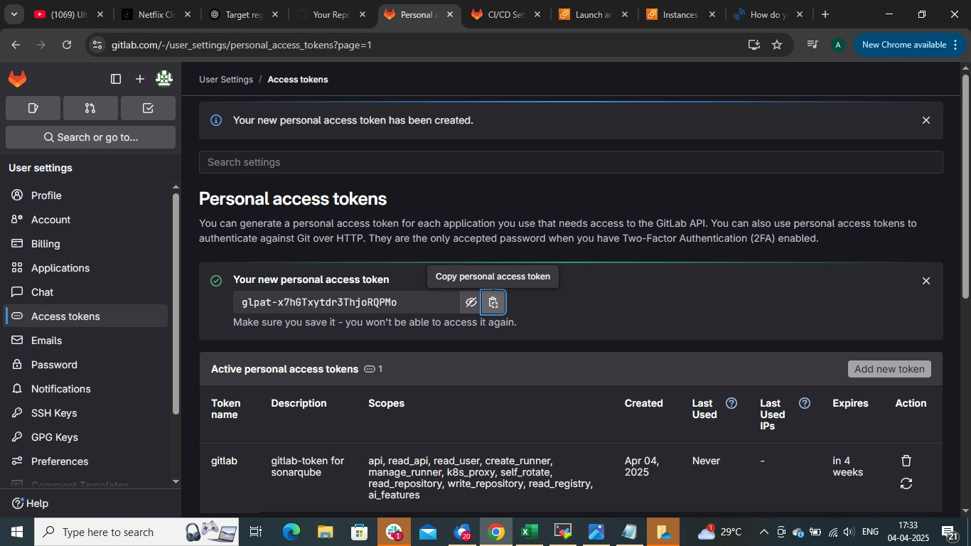

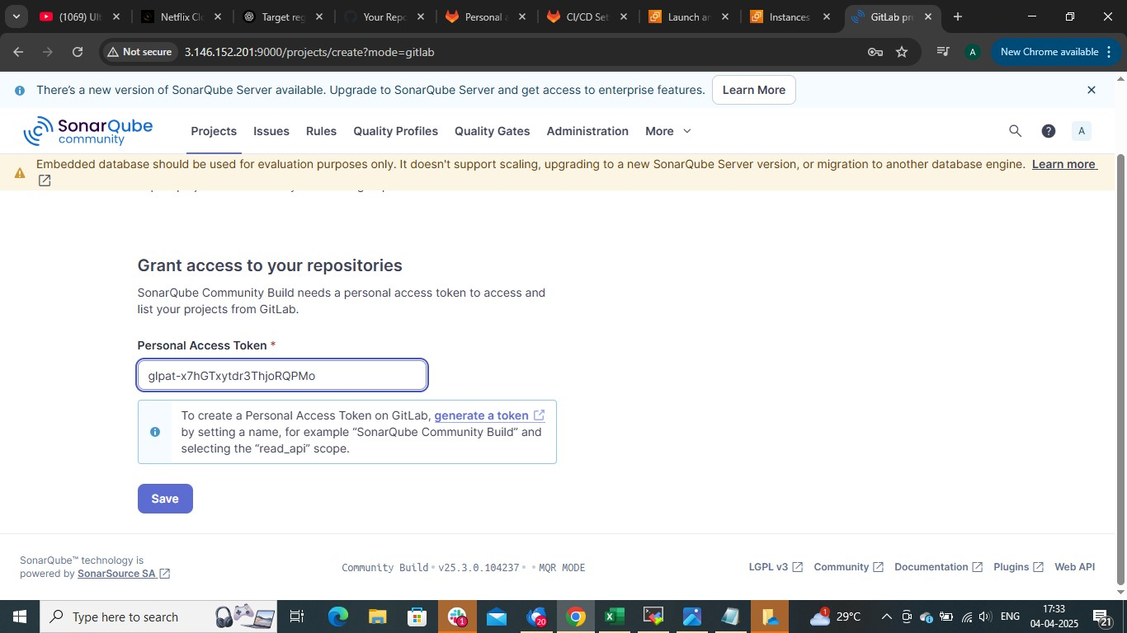

**Choose repo for which you are performing CICD**

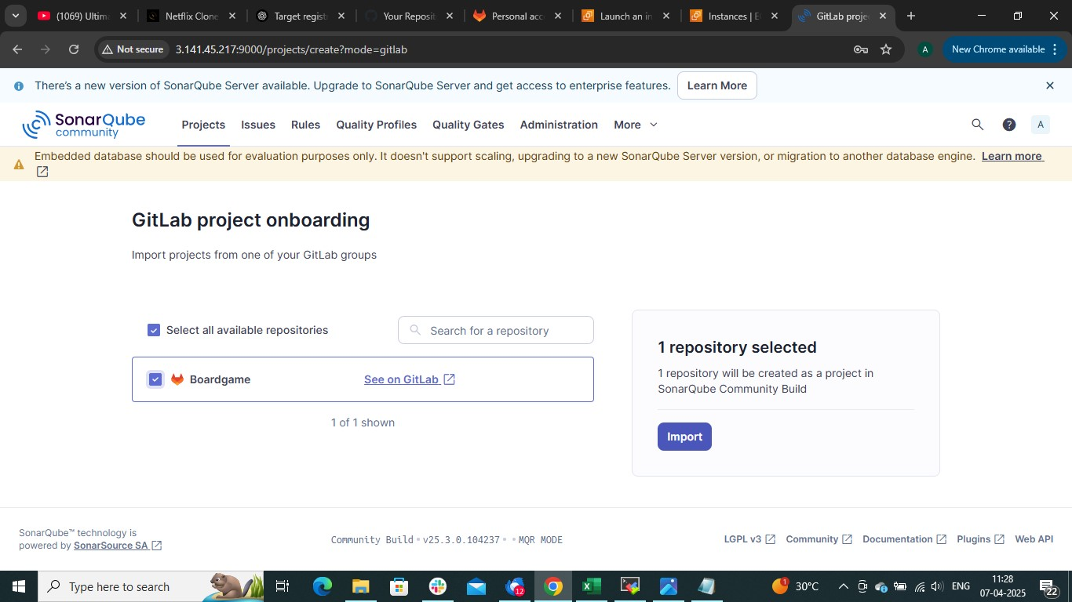

**🡺with gitlab CI**

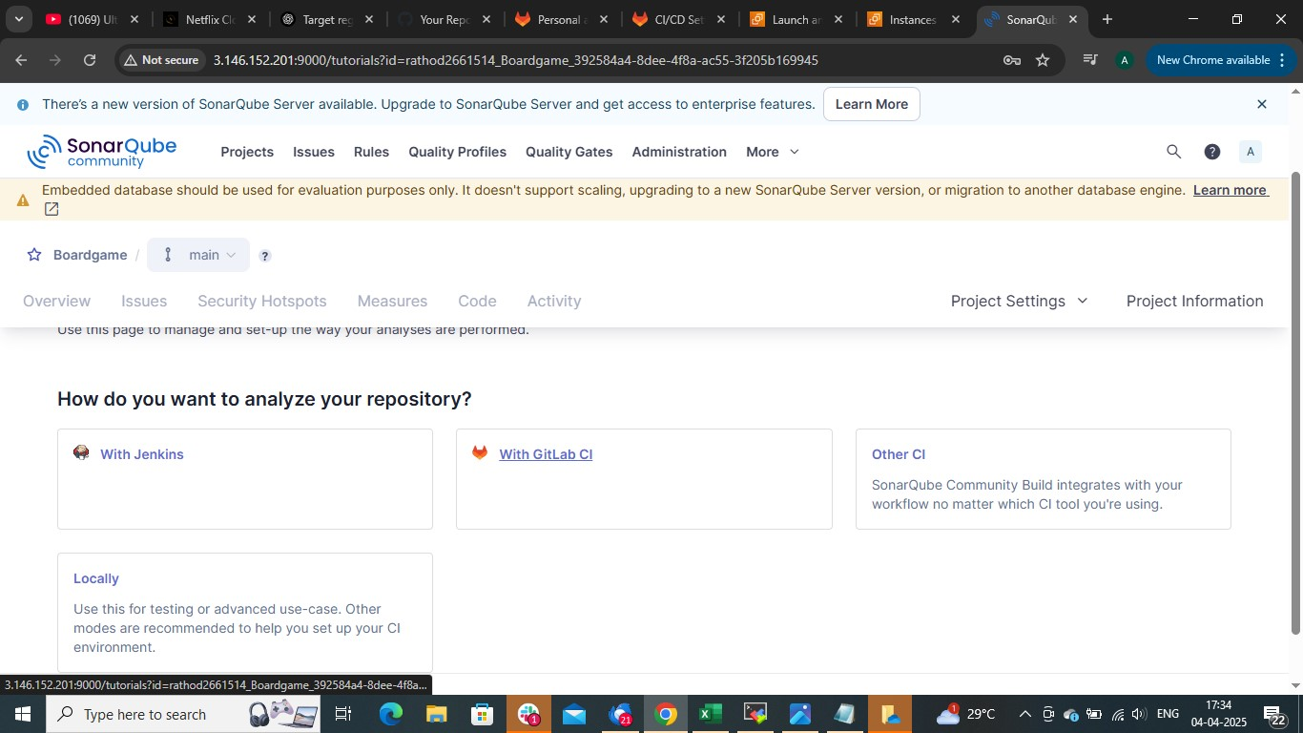

**Save these sonar_token and sonar_server_url in gitlab variables**

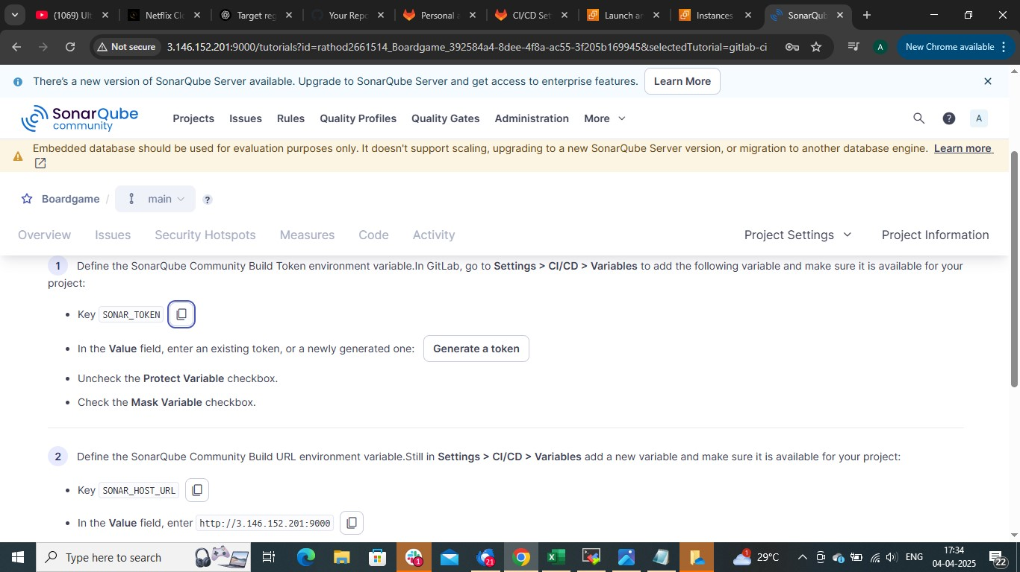

**🡺setting(left down)🡺CICD🡺variables**

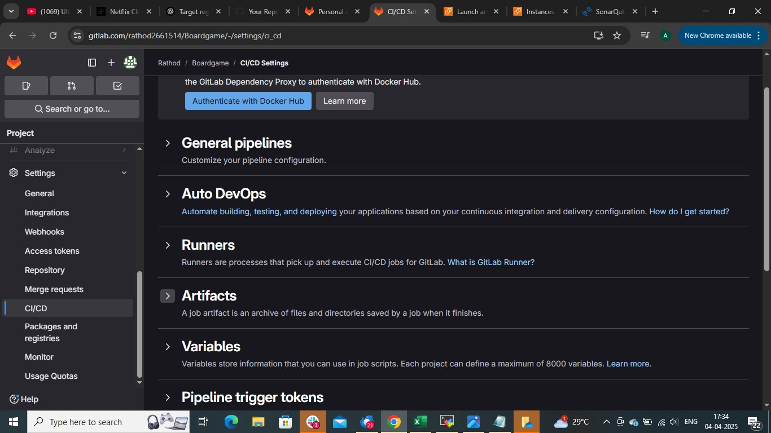

**🡺add variables**

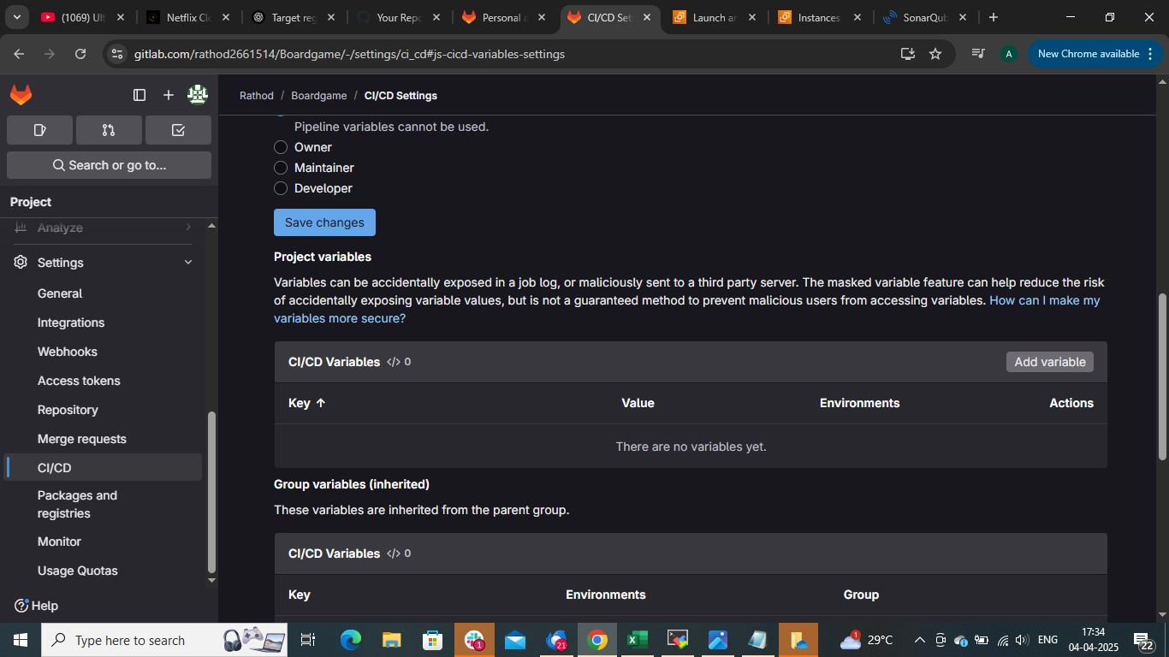

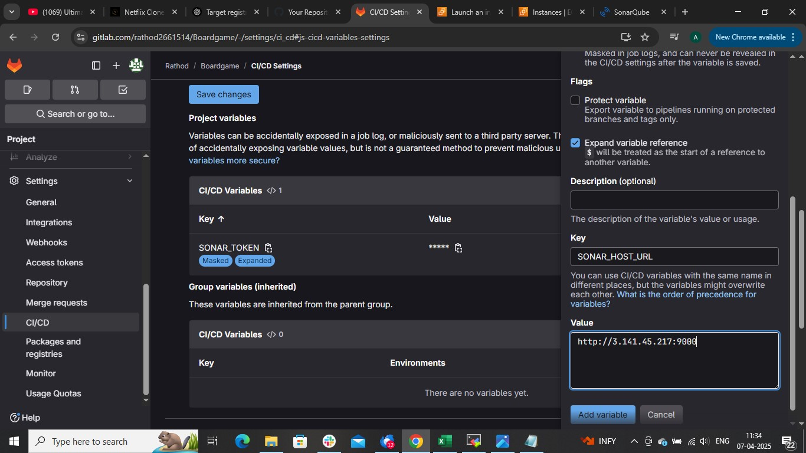

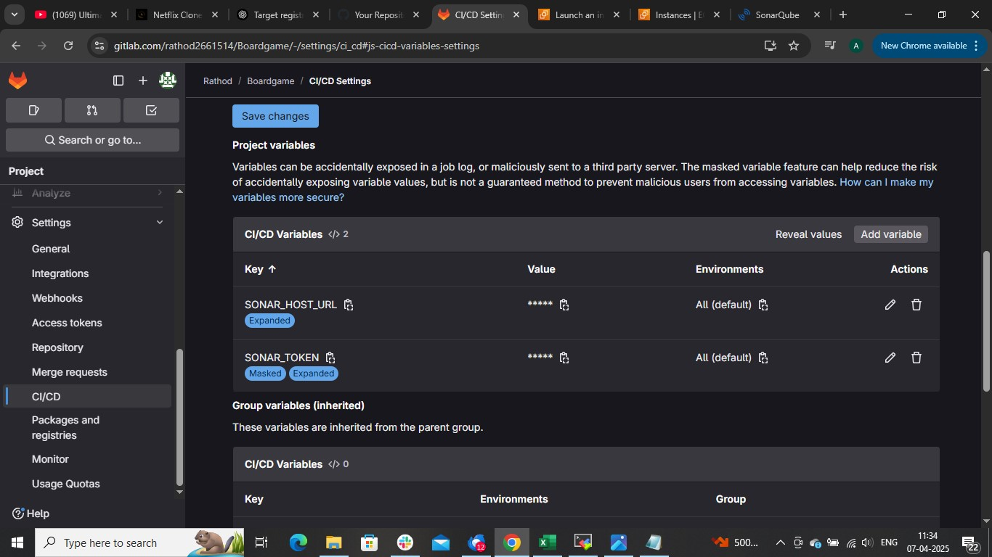

**🡺Others**

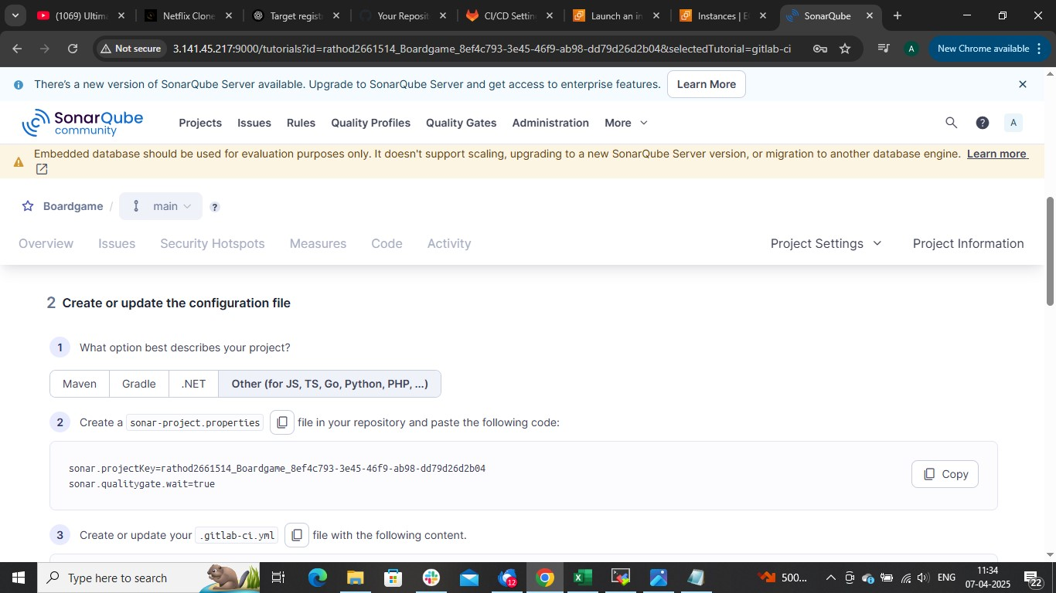

**Create sonar-project.properties in git repo and paste those following command**

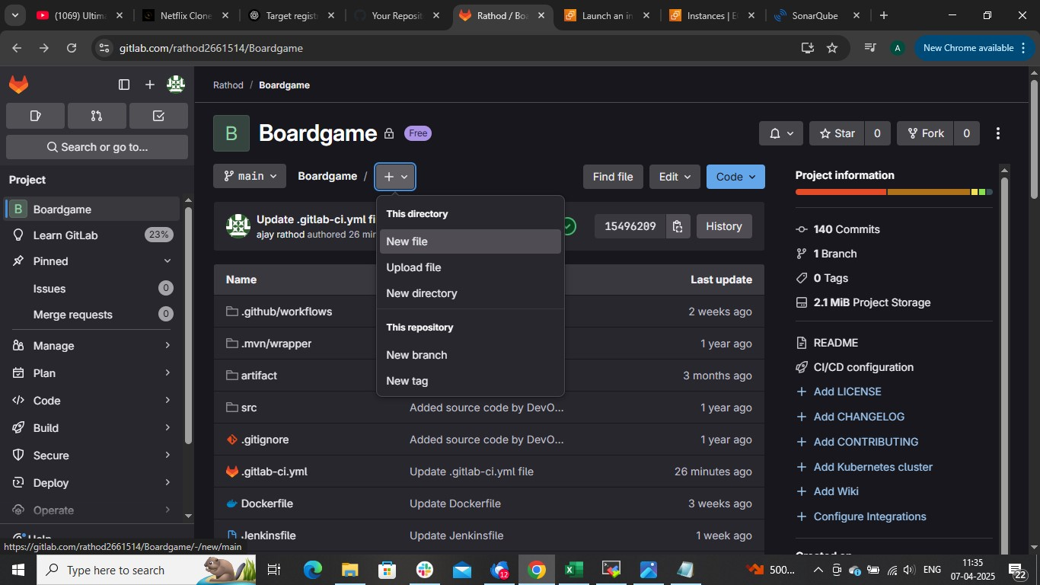

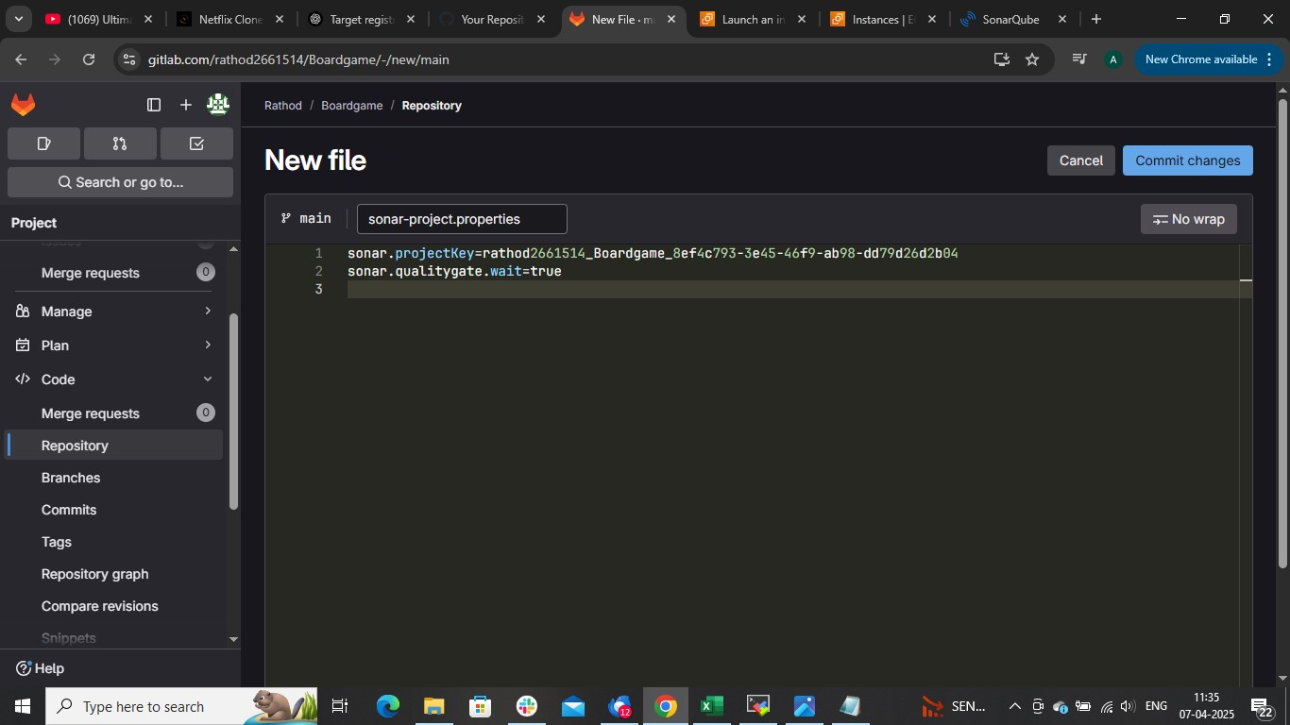

**And paste the remaing command in in cicd pipeline run the pipeline**

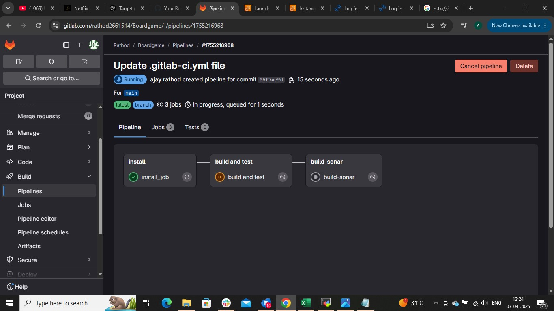



**If you don’t want to use sonarqube then skip the steps**

**Building and testing an application using maven**

**For this just add one more stage build in pipeline as shown and commit the pipeline**

stages:

    - install

    - build and test

    - build and push

    - deploy

# To install maven ,docker, and sonarqube

install_job:

    stage: install

    script:

        - sudo apt update -y

        - sudo apt install  maven -y

        - curl -fsSL https://get.docker.com -o get-docker.sh

        - sudo sh get-docker.sh

        - sudo systemctl enable docker

        - sudo systemctl start docker

        - sudo systemctl status docker

        - sudo docker rm -f $(sudo docker ps -a -q)

        - sudo docker run -td --name sonar-cont -p 9000:9000 sonarqube:latest

        - sudo docker ps

        - sudo apt install openjdk-11-jdk -y

        - export JAVA_HOME=/usr/lib/jvm/java-11-openjdk-amd64

        - export PATH=$JAVA_HOME/bin:$PATH

        - sudo snap install kubectl --classic

    tags:

        - ajay

build and test:

    stage: build and test

    script:

        - export JAVA_HOME=/usr/lib/jvm/java-11-openjdk-amd64

        - export PATH=$JAVA_HOME/bin:$PATH

        - mvn clean package

    tags:

        - ajay

**Hear ajay is the runner on which this pipeline run**

**Building docker image and pushing it dockerhub**

**First we need to store our dockerhub username and password in gitlab variable**

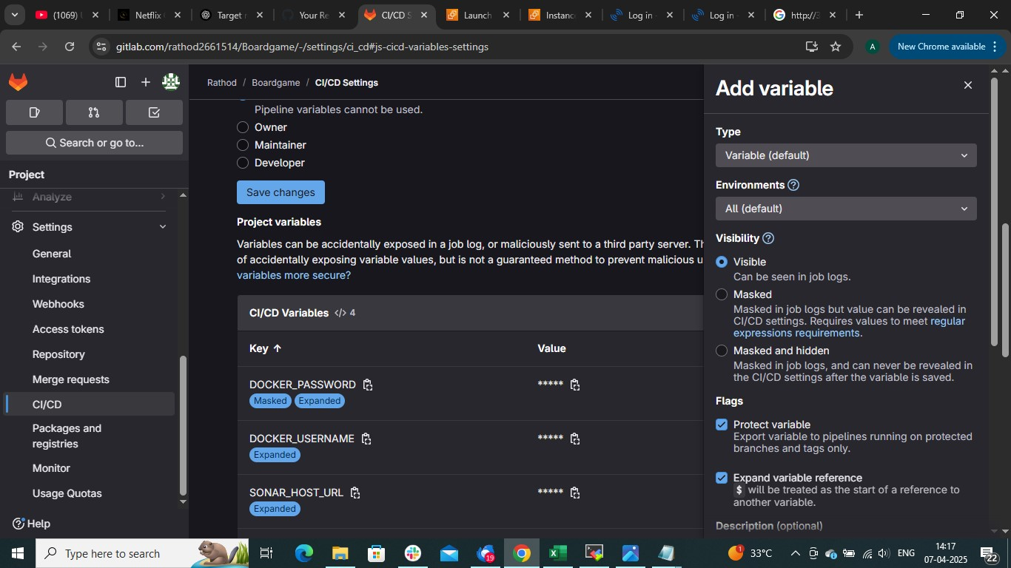

**Add this stage into pipeline**

docker_image:

    stage: build and push

    script:

        - export JAVA_HOME=/usr/lib/jvm/java-11-openjdk-amd64

        - export PATH=$JAVA_HOME/bin:$PATH

        - mvn clean package

        - sudo docker build -t ajjurathod1998/gitlab-image .

        - sudo docker login -u "${DOCKER_USERNAME}" -p "${DOCKER_PASSWORD}"

        - sudo docker push ajjurathod1998/gitlab-image

    tags:

        - ajay

**We have run this maven command docker build and push stage otherwise it will through an error saying jar file not found**

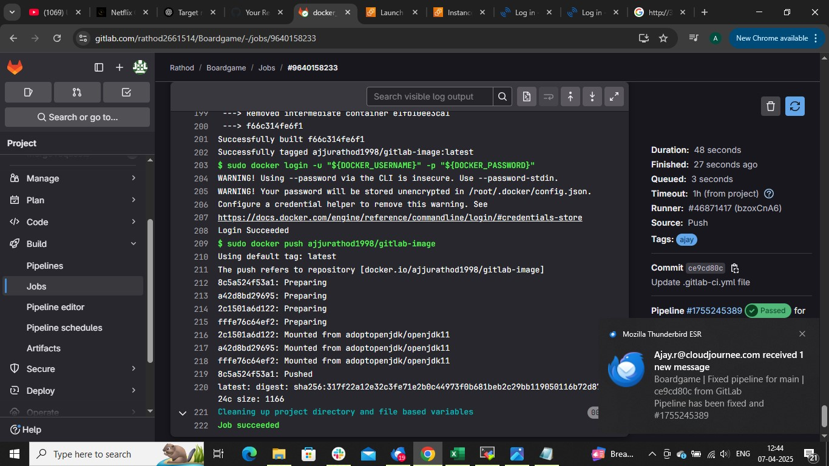

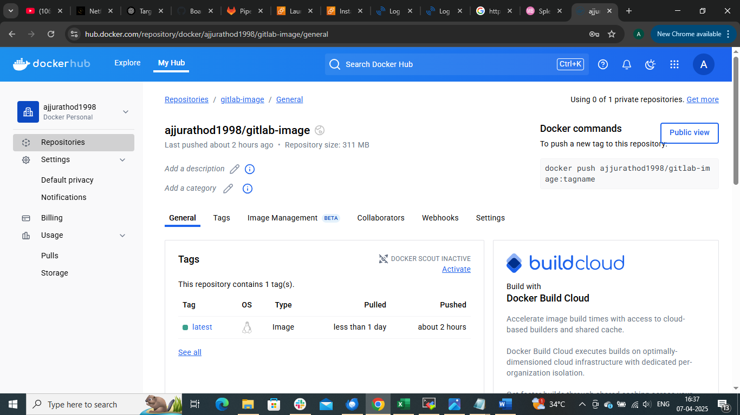

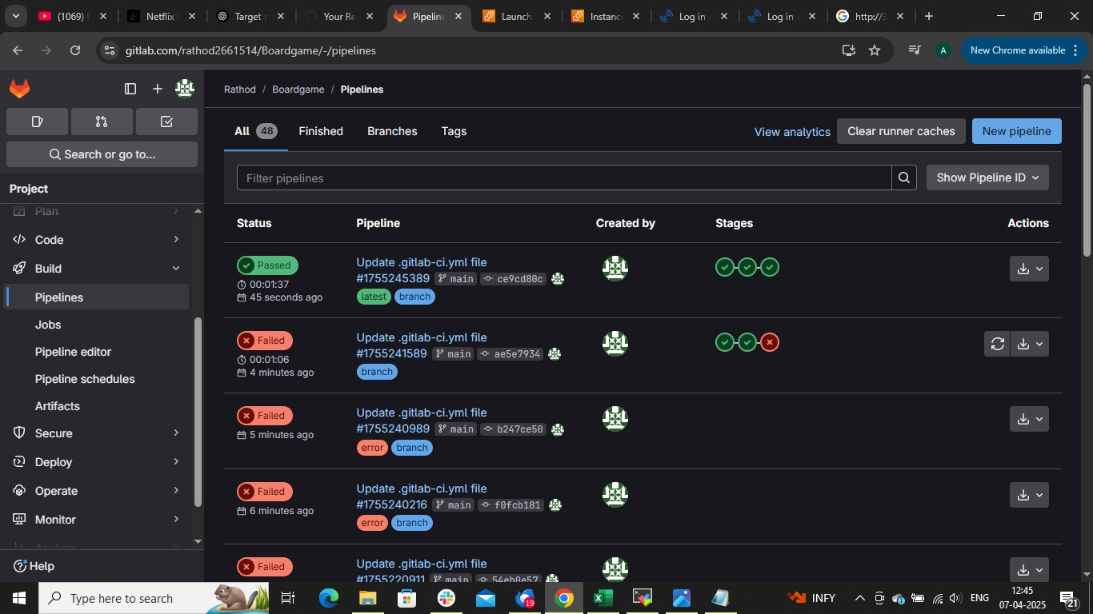

**Now to deploy application using Kubernetes**

**Install Kubernetes master and configure it worker node**

**On master node run command**

cat ~/.kube/config

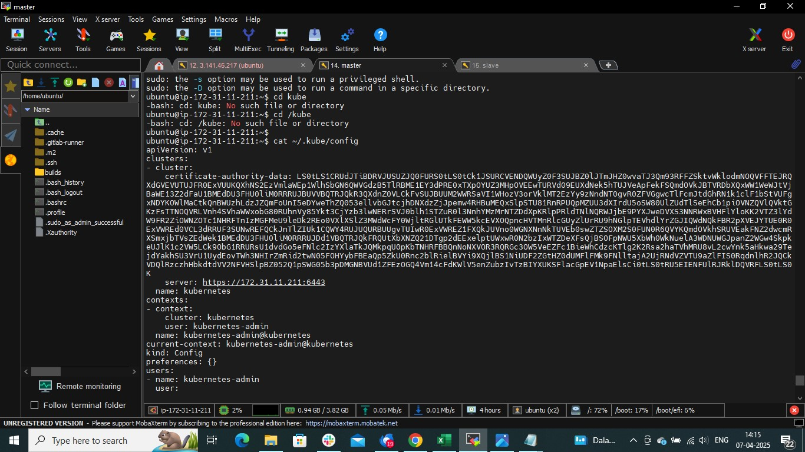

**Copy the whole above code and create variable in gitlab to integrate gitlab with k8s**

**(hear important to remember that variable type should be FILE)**

**🡺setting🡺cicd🡺variable**

**Change variable to file**

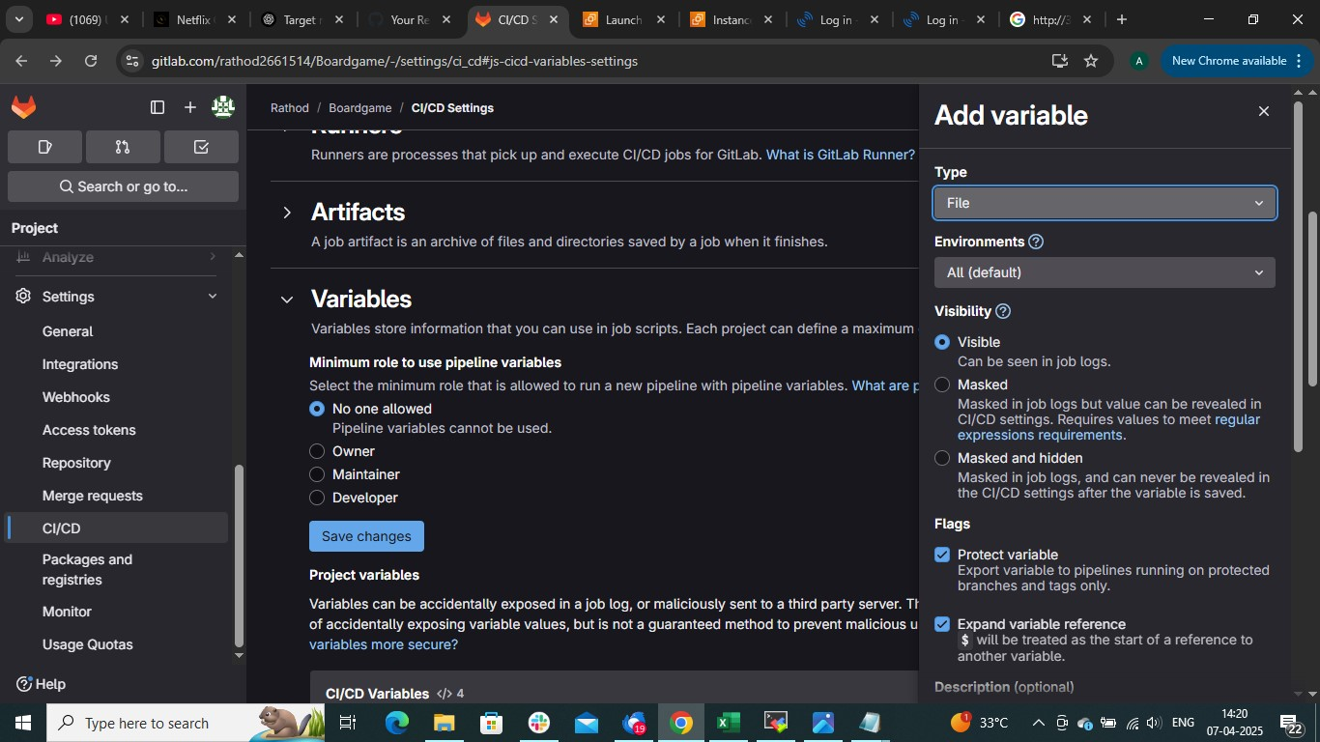

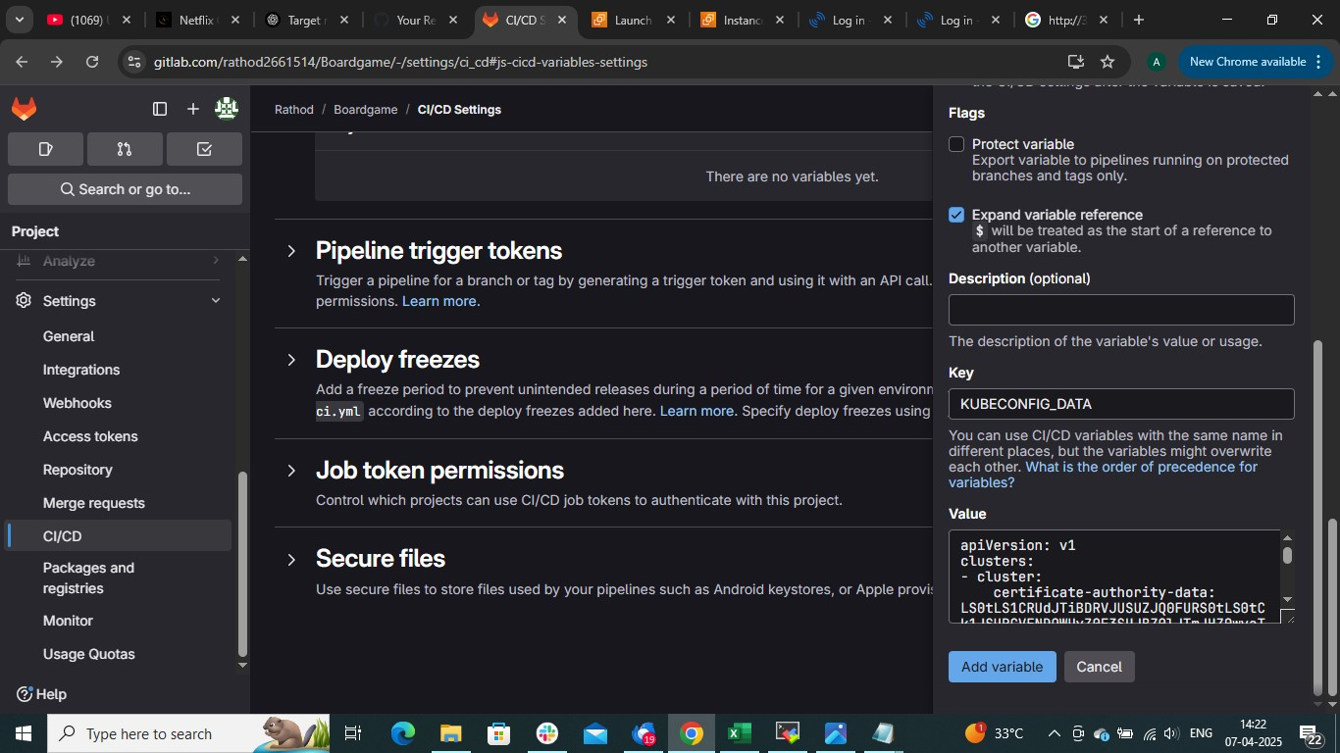

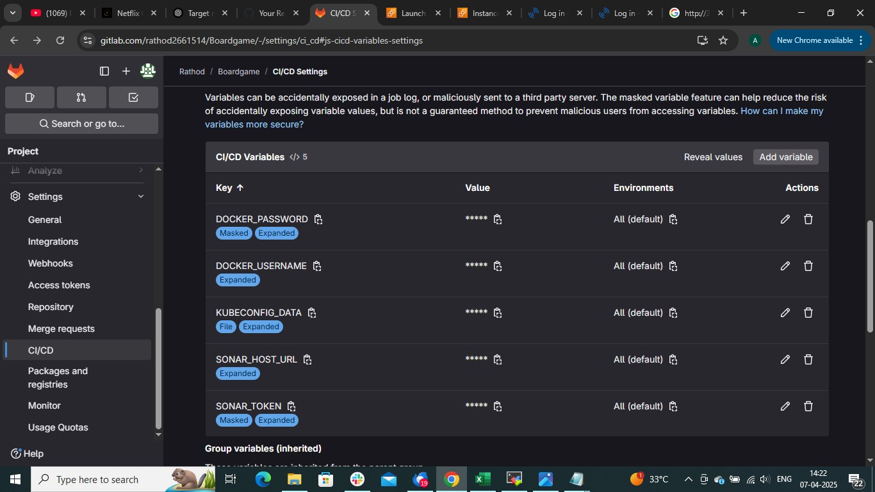

**That’s it now add more stage in pipeline**

deploy:

    stage: deploy

    script:

        - mkdir -p ~/.kube

        - cp "$KUBECONFIG_DATA"  ~/.kube/config

        - kubectl get nodes

        - kubectl apply -f deployment-service.yaml

    tags:

        - ajay

**The whole pipeline look like this**

stages:

    - install

    - build and test

    - build and push

    - deploy

# To install maven ,docker, and sonarqube

install_job:

    stage: install

    script:

        - sudo apt update -y

        - sudo apt install  maven -y

        - curl -fsSL https://get.docker.com -o get-docker.sh

        - sudo sh get-docker.sh

        - sudo systemctl enable docker

        - sudo systemctl start docker

        - sudo systemctl status docker

        - sudo docker rm -f $(sudo docker ps -a -q)

        - sudo docker run -td --name sonar-cont -p 9000:9000 sonarqube:latest

        - sudo docker ps

        - sudo apt install openjdk-11-jdk -y

        - export JAVA_HOME=/usr/lib/jvm/java-11-openjdk-amd64

        - export PATH=$JAVA_HOME/bin:$PATH

        - sudo snap install kubectl --classic

    tags:

        - ajay

build and test:

    stage: build and test

    script:

        - export JAVA_HOME=/usr/lib/jvm/java-11-openjdk-amd64

        - export PATH=$JAVA_HOME/bin:$PATH

        - mvn clean package

    tags:

        - ajay

docker_image:

    stage: build and push

    script:

        - export JAVA_HOME=/usr/lib/jvm/java-11-openjdk-amd64

        - export PATH=$JAVA_HOME/bin:$PATH

        - mvn clean package

        - sudo docker build -t ajjurathod1998/gitlab-image .

        - sudo docker login -u "${DOCKER_USERNAME}" -p "${DOCKER_PASSWORD}"

        - sudo docker push ajjurathod1998/gitlab-image

    tags:

        - ajay

deploy:

    stage: deploy

    script:

        - mkdir -p ~/.kube

        - cp "$KUBECONFIG_DATA"  ~/.kube/config

        - kubectl get nodes

        - kubectl apply -f deployment-service.yaml

    tags:

        - ajay

**Commit the changes**

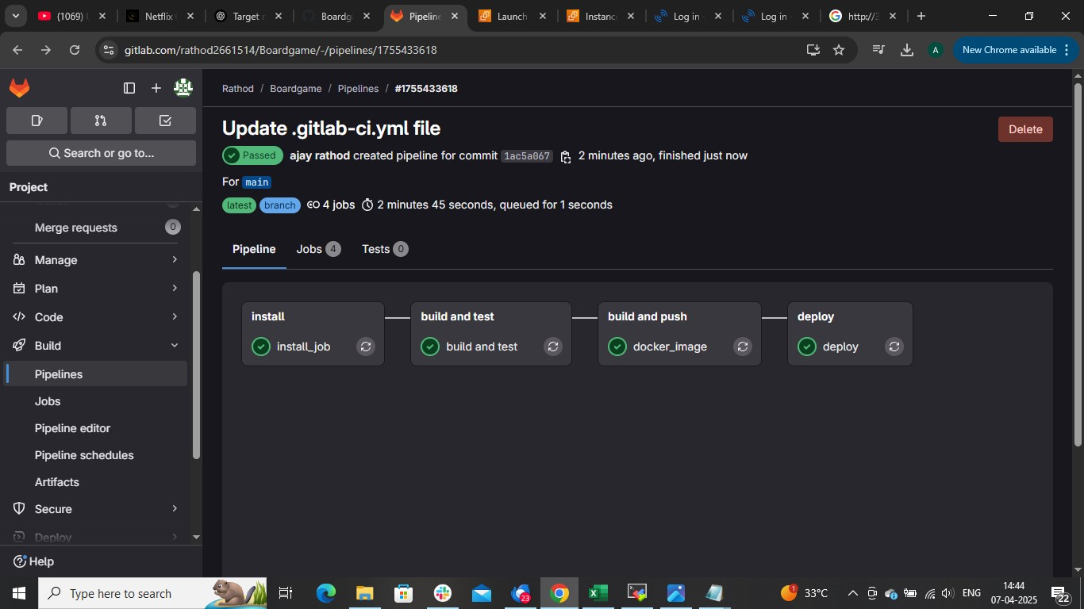

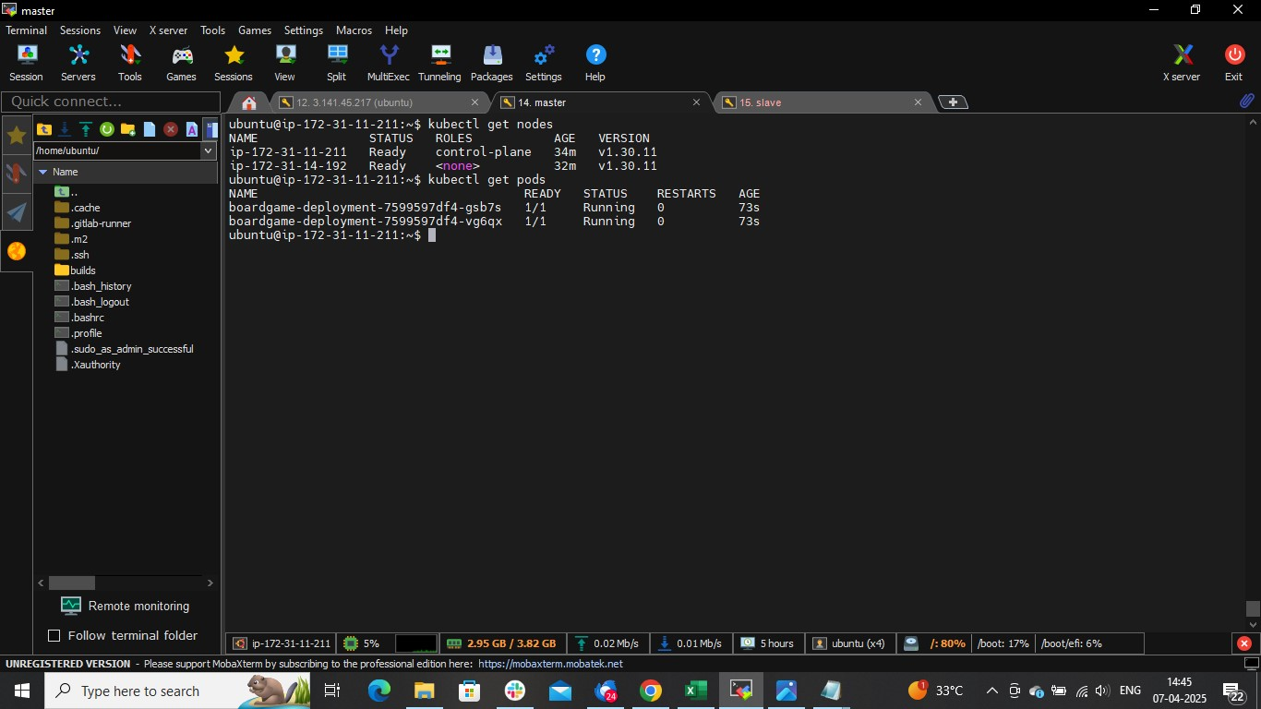

**Copy the public Ip of worker and nodeport of service**

**Publicip:Nodeport**

